Задание 3

Desktop publishing

Reading

25 new words learning and explaining them in English

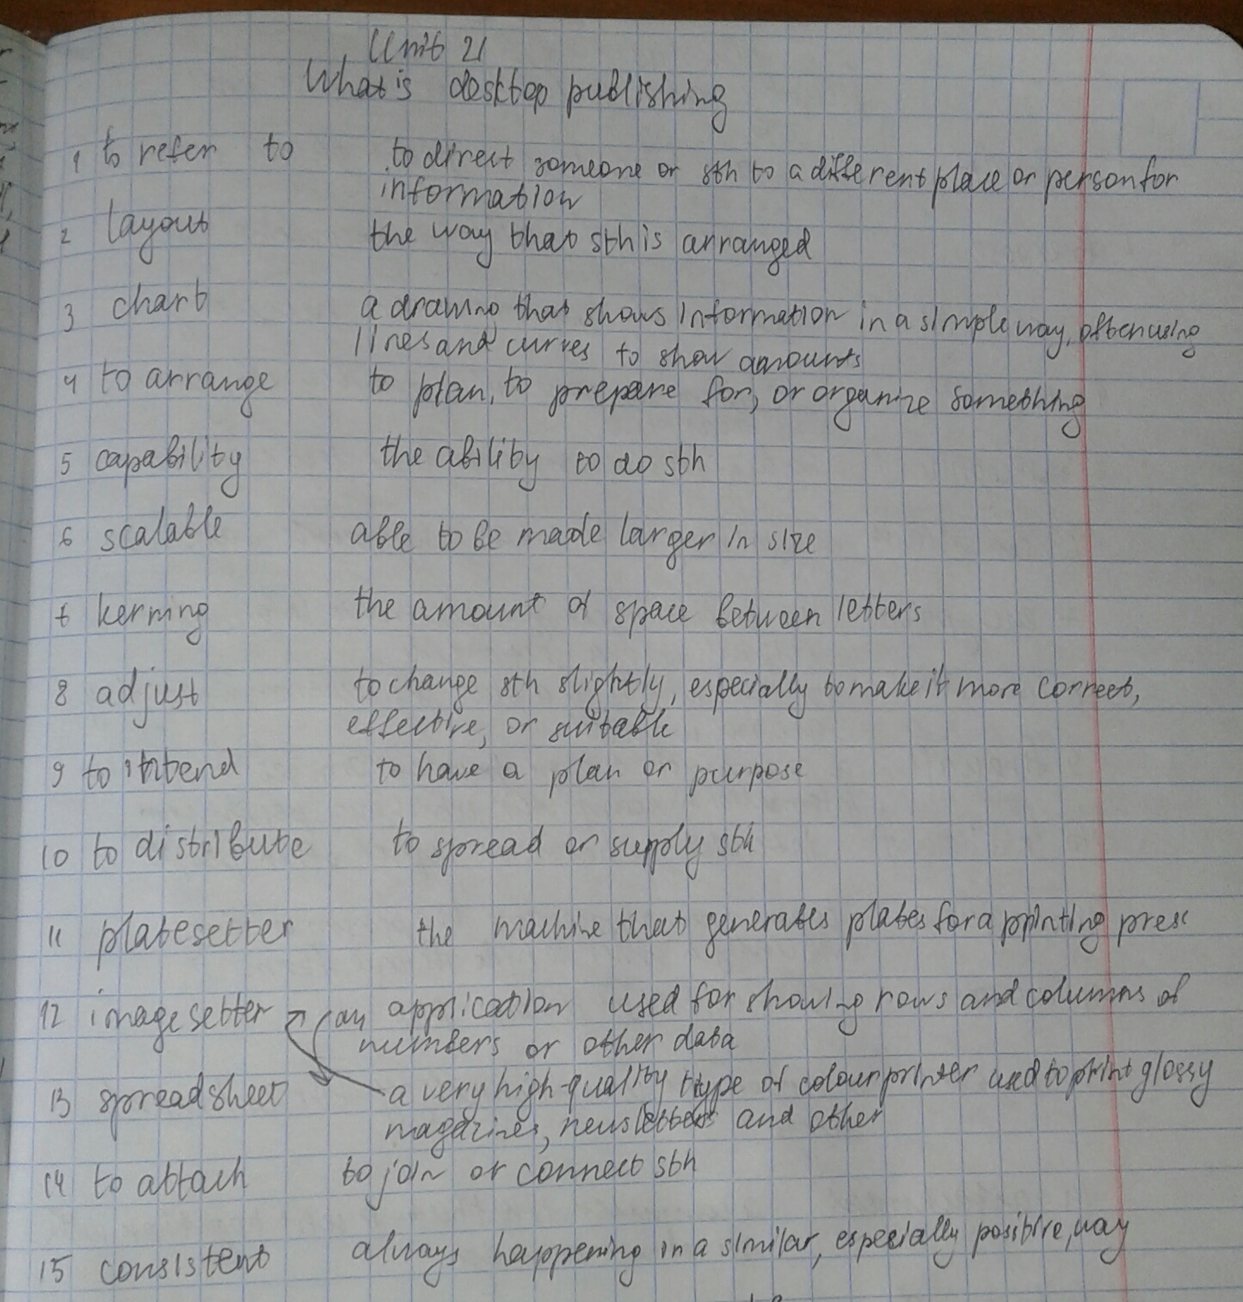

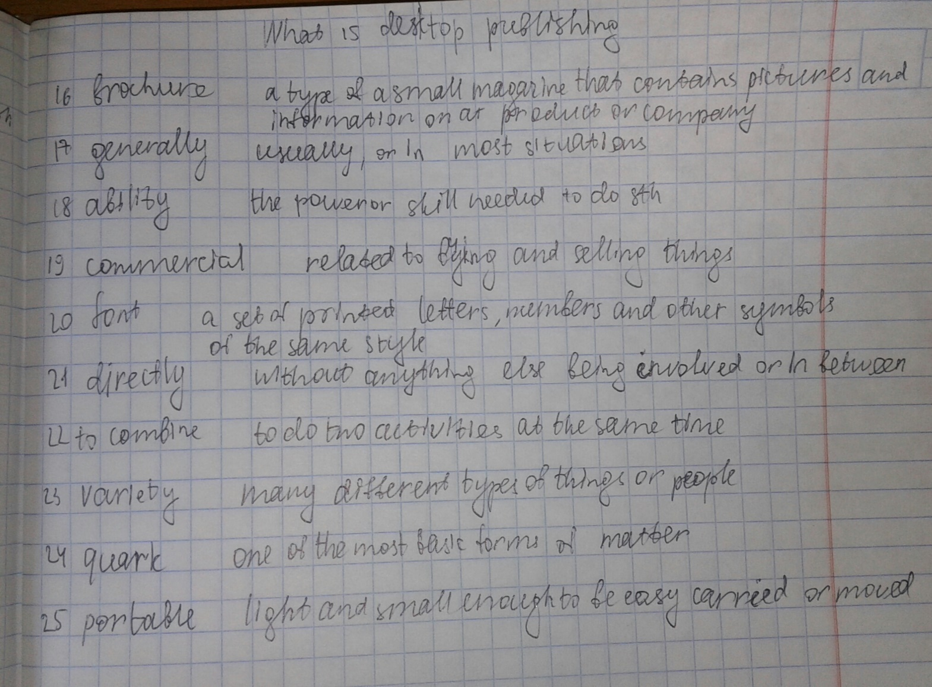

Thinking about the key component of a desktop publishing system

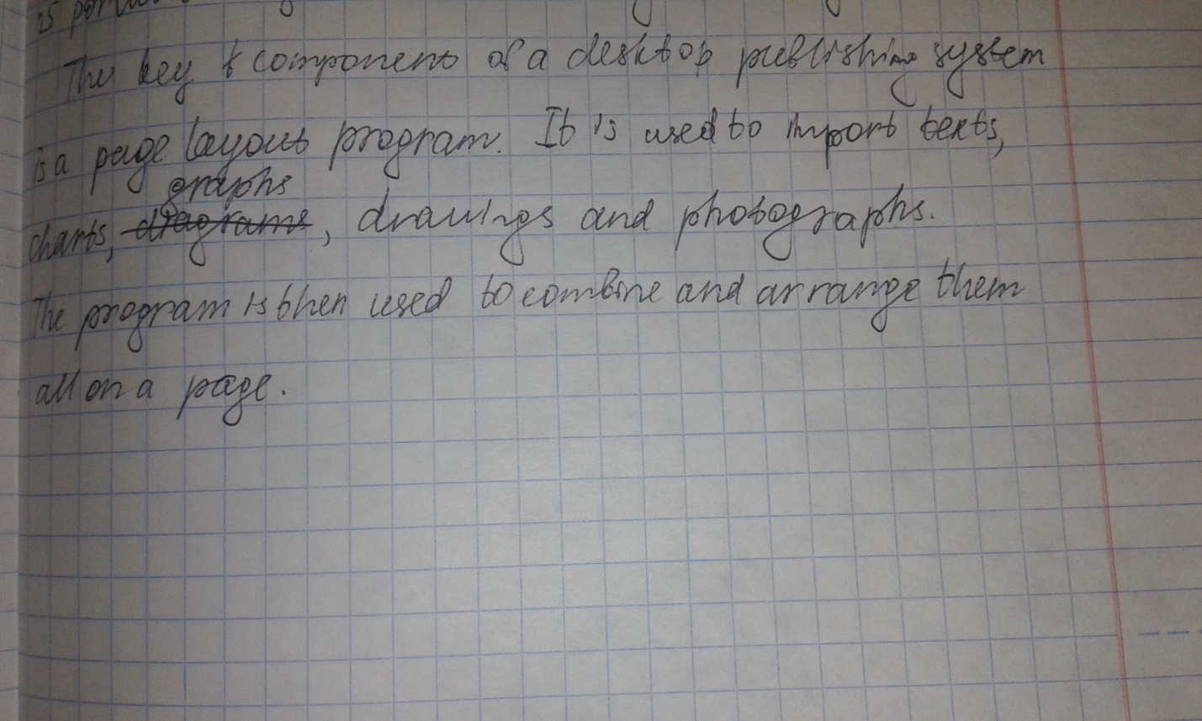

Look at this extract from an online tutorial for Desktop publishing and

put the steps in the creation of a Desktop publishing documents (a-f) into the correct order.

Listening to the audio from the online tutorial and check your answer to A (p.107)

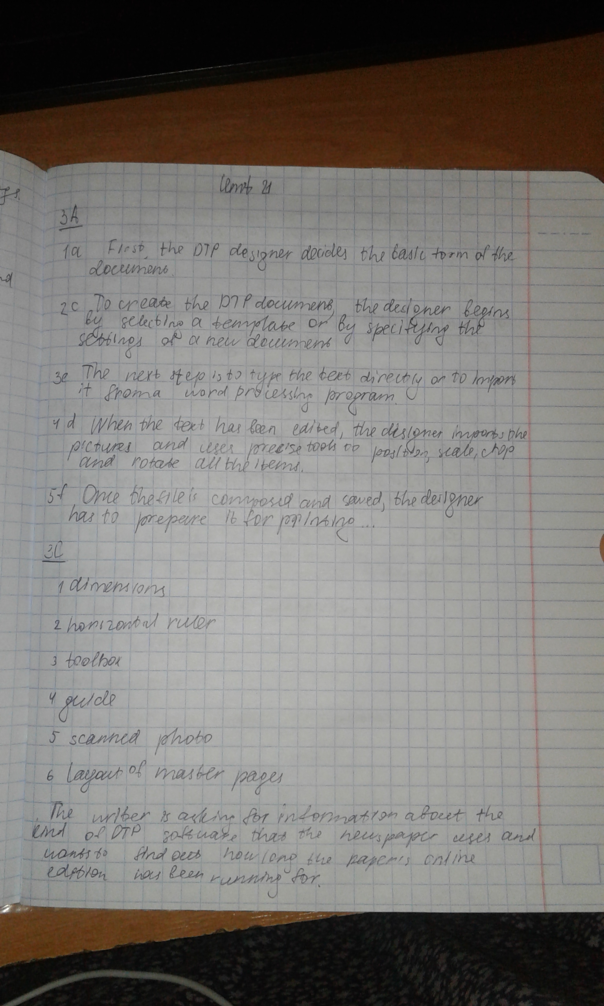

Label the feature of this page designed with Adobe in Design with the words from the box (p108)



Formal letter

What is the writer asking for?



Match the parts of the letter with the descriptions.

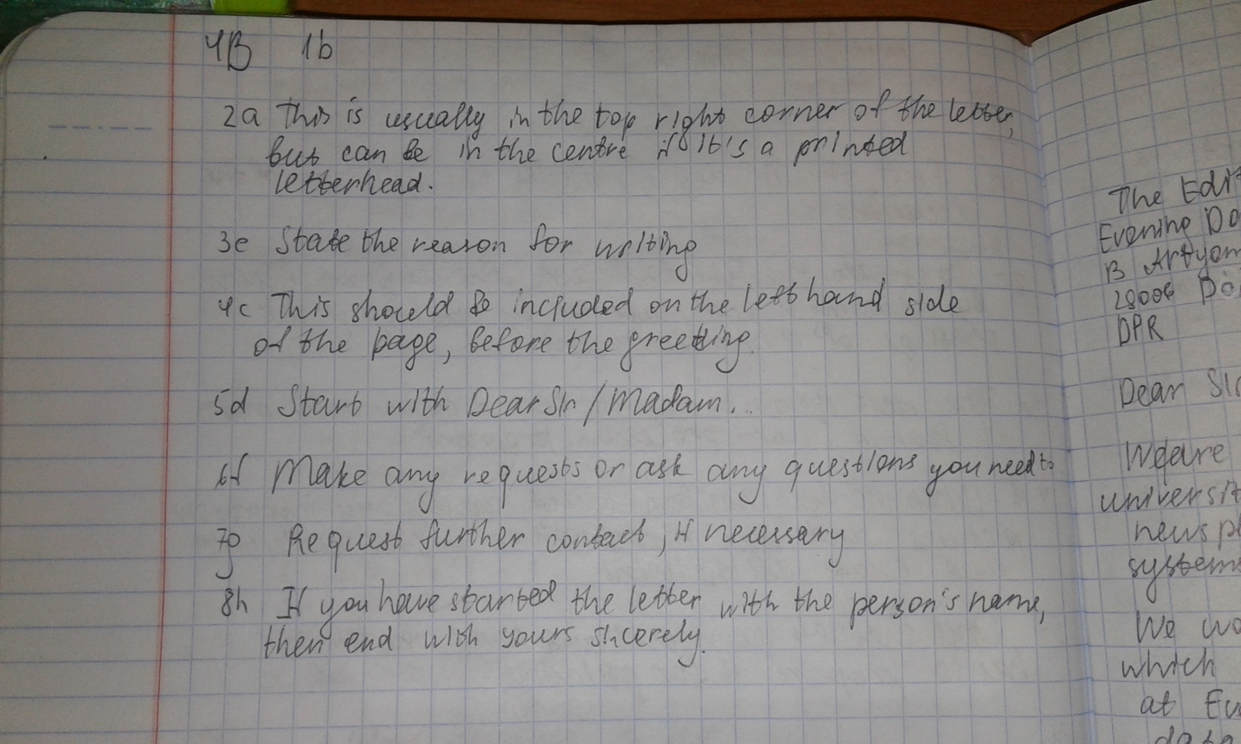

Write the letter asking for information about hardware, page layout

software and data communications system usage.

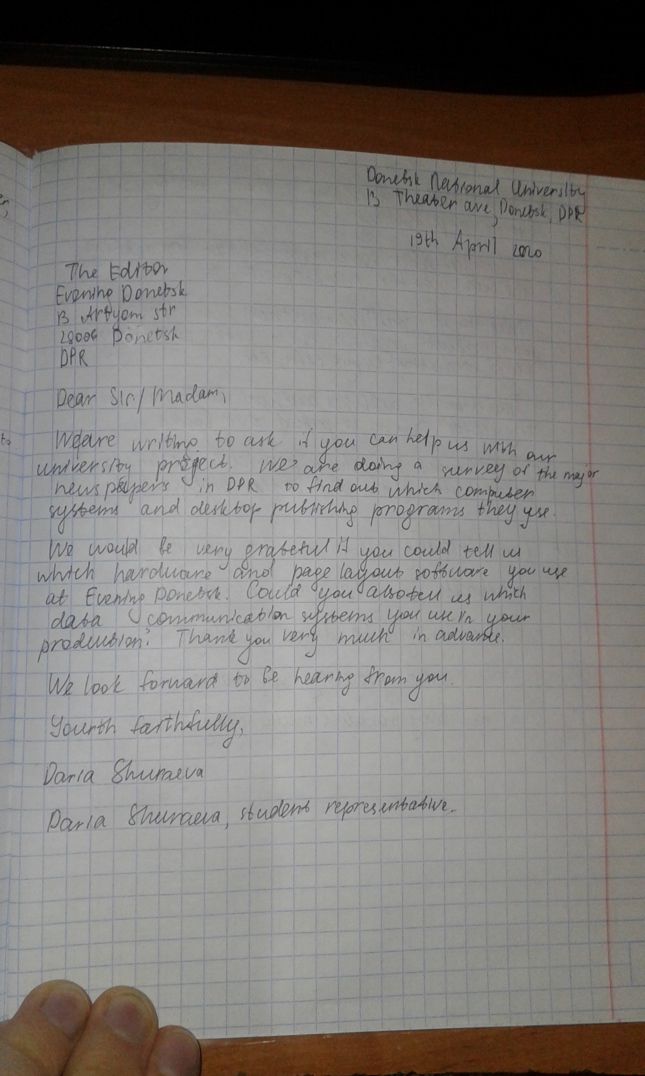

Writing 5 sentences about the advantages of traditional publishing over e-publishing.

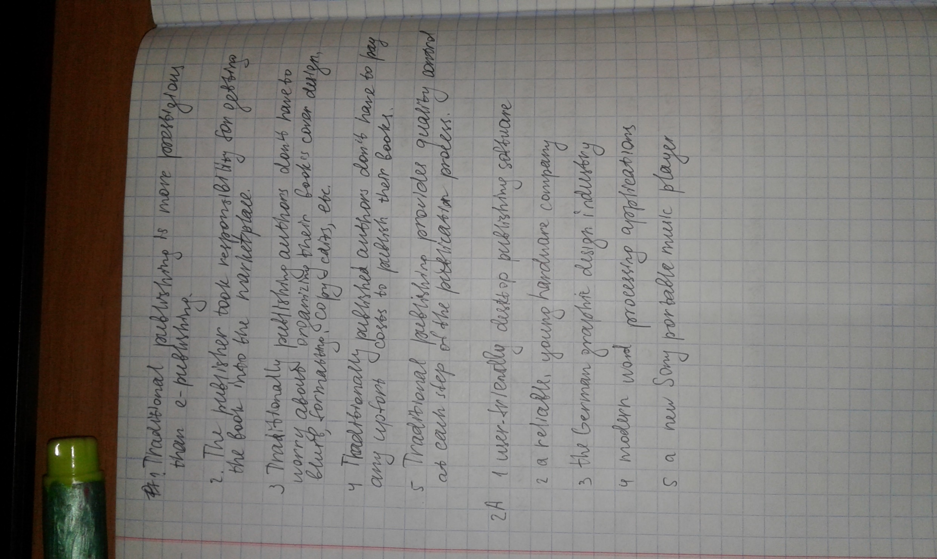

Exercise A and B p 106-107

